Identification of a Deep Learning Technique for Facial Emotional Datasets for Song Recommendation System

Dr. Albert J Mayan 1, Dr. Mary Posonia 1, Hariharan B P 1, Jagadeesh N and Mohnish Devaraj

*Department of Computer Science Engineering  
(of Affiliation)*  
Sathyabama Institute of Science and Technology *(of Affiliation)*Chennai, India.  
albertmayan@gmail.com 2

*Department of Computer Science Engineering  
(of Affiliation)*  
Sathyabama Institute of Science and Technology *(of Affiliation)*Chennai, India.  
[maryposonia.cse@sathyabama.ac.in](mailto:maryposonia.cse@sathyabama.ac.in)

*Department of Computer Science Engineering  
(of Affiliation)*  
Sathyabama Institute of Science and Technology *(of Affiliation)*Chennai, India.  
[bphariharan1301@gmail.com](mailto:bphariharan1301@gmail.com)

*Department of Computer Science Engineering  
(of Affiliation)*  
Sathyabama Institute of Science and Technology *(of Affiliation)*Chennai, India.  
[jagadeeshshirs6453@gmail.com](mailto:jagadeeshshirs6453@gmail.com)

*Department of Computer Science Engineering  
(of Affiliation)*  
Sathyabama Institute of Science and Technology *(of Affiliation)*Chennai, India.  
mohnish.devaraj312002@gmail.com

**Abstract.** An Android application called "SONG Recommender System Using Emotion Detection" allows users to play music in accordance with their mood (emotion). The user can choose their language and employ emotion recognition using this app. All the prior research employed various algorithms, such as fisher faces, SVM, K-nearest algorithms, etc., however those methods were not always effective. Recent research recommended combining emotion recognition (ER) with deep learning (DL) applications to lessen the amount of manual work required from the user to search for and listen to songs. Convolutional neural networks (CNN) can be used to determine users' emotional recognition using the FER2013 dataset, according to this systematic review.

**Keywords:** Convolutional Neural Network, Deep Learning, Song Recommender, Face Recognition, Feature extraction, Emotion detection, Music Player, Camera.

**1 Introduction**

By identifying and capturing the user's emotions in real time, this notion suggests music to the user. We presented a method to categorize various types of music into distinct moods, such as joyful, sad, irritated, etc.

Existing techniques that were employing collaborative techniques that would use user’s data from prior sessions to select music. However, these strategies take a lot of manual work.

Additionally, the branch of research known as Computer Vision (CV) enables computers to learn by employing various strategies and methodologies in order to capture what is present in an image or a video. Currently, computer vision has a diverse array of applications, such as recognizing faces, autonomous vehicles, medical analysis, and more. Today, we will delve into the exciting field of detecting emotions through facial expressions, a noteworthy use of CV. By seeing the facial expressions, the model can identify and describe your sentiment.

**2 METHODS**

This study is solely focused on determining the best deep learning (DL) algorithm for emotional recognition that provides almost perfect accuracy. The necessary data was collected using a systematic review process, and quantitative methods were used to analyse and filter the data collected in accordance with the needs of the study.

In this work, the following critical methods have been applied: -

1. Facial Detection — The capability to detect a face in any given image or frame using facial detection. The results are the detected faces' bounding box coordinates.
2. Facial Recognition—To determine which faces belong to the same person, compare various faces together. Comparing facial embedding vectors allows for this.
3. Emotion Detection — identifying the various facial expressions as pleased, angry, sad, neutral, or surprised.

***FORMULATING RESEARCH INQUIRIES (RQ):***

The subsequent Table 1 presents the formulated research questions, aligned with the author's underlying motivation for conducting this study.

|  |  |  |
| --- | --- | --- |
| S. No. | Questions | Solutions |
| 1 | Which is the optimal choice DL technique for emotion recognition? | Various researchers have employed various DL techniques but, we are yet to know which has the near perfect accuracy. |
| 2 | Which freely accessible face dataset would be the most appropriate for training and testing the developed project? | Researchers have used various datasets to train their particular model but, for our study we have chosen  The FER2013 datasets from Kaggle which has a wide variety of data in it (50,000) and the test accuracy has Reached 63.2%. |

**3 LITERATURE STUDY**

Here, we will describe what other recommendation system has and used in their attempt to develop this kind of application. Examining the techniques is carried out to understand their weaknesses and how to improve them. The text of an academic document, commonly referred to as a literature study, encompasses the latest research findings and key theoretical and methodological advancements in a specific field. There is worldwide interest among students, researchers, engineers, and other professionals In the hidden capacities of individuals to provide inputs to systems through various means. Facial expressions can give insight into a person's emotional state. Within the realm of interpersonal communication., we often convey the emotions through hand gestures, facial expressions, and vocals. Many users have reported the process of crafting and sustaining an extensive playlist requires a significant amount of effort. considerable amount of time. According to the report, the music player adapts to the user's mood and selects a song accordingly. To generate mood-based playlists, the application classifies audio files based on audio attributes. To evaluate the efficacy of the developed model, SVM were used to categorize features into five major universal emotions: anger, joy, surprise, sadness, and disgust.

Like previous author said “ Human express his or her emotion through face”[1] it becomes really important to look for various application(s) to use this potential feature. And that’s when the Music recommendation came into picture. We are trying to develop an application which suggests the songs to the user based on his/her choice of language and the emotion he/she is in.

In this section, we will present and summarize the latest research on the utilization of Convolutional Neural Networks (CNN) in the field of digital image processing. Each individual possesses a unique facial expression that reflects their emotional state. This phenomenon holds true across various domains, encompassing automated machines, medically, manned aircraft, and lie sensors, facial expressions can serve as versatile instruments, offering a range of communication tools. The facial expressions listed below are derived from our understanding of emotions: anger, fear, happiness, sadness, disgust, neutrality, and surprise. Facial emotion recognition using convolutional neural networks has recently been presented by Ninad and his research team. The idea is separated into two main segments. Initially, the background is eliminated from the photographs, while the subsequent step concentrates on a specific aspect of image processing known as vector extraction. The researchers utilized data from a monitoring system that consisted of 10,000 pictures and a database containing 154 faces. The results of their study demonstrate that when utilizing a model that incorporates 24 numerical values to represent facial expressions, the accuracy reaches around 96%. Notably, the researchers relied on face data storage from Cohn-Kanade, Caltech, CMU, and NIST in their investigation. Which uses more than 750k datasets of photos. [13]

Ajinkya Khobragade [2] suggested a song recommendation system utilizing Python and Tableau, but he desired for this system to operate in a real-time setting and to capture the alignment of the facial structure to be developed for the comfort of users.

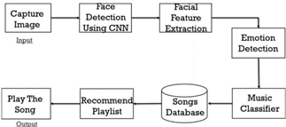

Fig 3.1: Yusuf’s work flow

Yusuf Yaslan[12] and his colleagues proposed a music recommendation system that utilizes emotions as its basis. that utilizes wearable technology with physiological sensors for GSR and PPG to detect the user's emotions. Emotions serve as a key element of human nature and play a vital role in our lives. This study uses multi- channel physiological signals to predict arousal and valence in order to address the difficulty of emotion detection.

According to Ayush Guidel et al., facial expressions make it simple to determine a person's emotional state of mind at any one time.

**4 PROPOSED SYSTEM OVERVIEW**

The interaction between the user and the music player. in the suggested system is advantageous to us. The objective of the system is to utilize the camera for acquire a facial image. The CNN then utilized to forecast the emotion using the captured visuals. A customized list of songs is created based on the detected response in the captured image. The objective of the system the objective is to generate automatically. a music list that reflects the user's responsiveness.

The response-based music system comprises four modules.

* On-spot Capture: System must accurately take the person response.
* Face Recognition: Here, the person response will be used like data. The CNN is set up to analyze the pictorial characteristic of a person.
* Emotion Detection: In this stage, the user image's features are extracted in order to identify their emotions, and the algorithm then generates captions based on those emotions.
* Music Recommendation: By matching the user's emotions to the song's mood type, the recommendation module suggests songs to them

**5 METHODOLOGY**

The dataset was taken from Kaggle to create the CNN model. The dataset, FER2013, is split into combination of two different dataset, said to be training and testing dataset. There are total of 30,219 pics of data, in which 80% (24,176) is used for the Training the model and allocating 20% (6043) used for testing. The collection contains 48x48 pixel grayscale portraits of data. In FER-2013, each data is assigned to a particular emotion among the set of five pre-loaded dominant expressions such as neutral, happy, sad, angry, and surprised. Faces present in the image are automatically recognized in order to make sure it is approximately centered and occupies the same amount of area in each photograph. Google image searches for every emotion which were used to compile the dataset.



Fig 5.1 An Angry Face

When trained, the datasets with unequal distribution of emotions, facial expression recognition systems may excel in recognizing dominant expressions such as mentioned above, but fall short in accurately identifying less frequently represented emotions.

A more detailed view on how the algorithm works: -

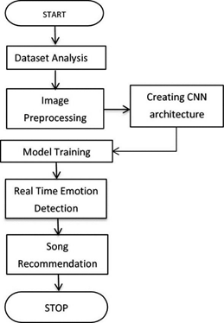

Fig: 5.2 Algorithm Flow Chart

This issue is typically addressed using the weighted-SoftMax loss strategy attempts to address this issue by assigning higher weights to the underrepresented classes. This way, the model is encouraged to pay more attention to the underrepresented classes and improve its accuracy in recognizing them. The weighted-SoftMax loss is obtained by calculating the cross-entropy loss by comparing the predicted probability distribution with the true distribution. where the weights are applied to the true distribution. We have applied the categorical cross-entropy loss function to handle missing and outlier values. A chosen loss function is used for each iteration to estimate the error value. Therefore, the utilized loss function called categorical cross-entropy to treat missing and outlier values.

The CNN has 6 Convolutional Layers (CL), 2 subsampling, 12 CL & 2 subsampling NN.

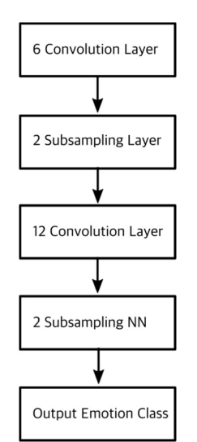

Fig 5.3 CNN Architecture

Convolutional Layers: -

In order to extract features from the input image, a convolution layer alters it. The image is convolved with a kernel (or filter) in this process. The architecture consists of multiple filters (or kernels) that undergo training to learn their optimal settings. Generally, these filters have smaller dimensions than the original image. Upon convolution with the image, each filter generates an activation map. The final element of the an activation function within a convolutional layer enhances the nonlinearity of the output. Commonly used activation functions include ReLU and Tanh activation functions in convolution layers. Here is an illustration of a straightforward convolution layer, in which a 6x6x3 input picture is convolved with two 4x4x3 kernels to produce a 3x3x2 convolved feature, to which an activation function is applied to produce the output, also known as a feature map.

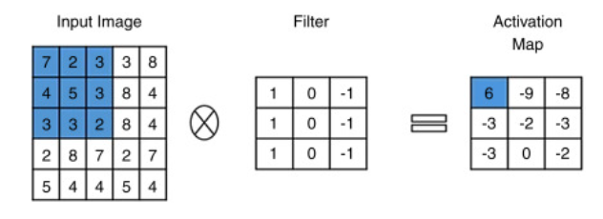

Fig 5.4 Subsampling Layer

Subsampling Layers: -

By choosing a subset of the original data, subsampling is a technique that is used for reducing the amount of data. By selecting the parameter n, which indicates that each subsequent data point is to be extracted, the subset is defined. For instance, picking every nth point in structured datasets like image data and structured grids yields the desired results. An altered dataset's structure results from subsampling. A topological "hole" results from not selecting any points or cells. To close the gap, the dataset topology needs to be changed. In structured data, a uniform selection is made across the structured i-j-k coordinates. However, when there are gaps in the structured data, they need to be filled using techniques such as triangulation or other methods. intricate tessellation techniques. Unstructured data often does not undergo subsampling due to its intrinsic complexity.

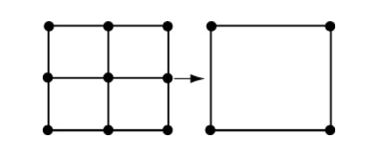

Fig 5.5 Activation Map

# Steps:

**Step 1**: The user provides input in the form of a captured image using the camera.

**Step 2**: The image is then analysed by the model and gets classified into a particular category of emotion.

**Step 3**: The data is extracted and detected using the training datasets, specifically the Fer-13 datasets.

**Step 4**: A particular customized list of songs(playlist) is chosen according to the user’s emotion.

**Step 5**: The music is played depending on the emotion to of the user.

# Face Detection:

One of the uses of Computer Vision is facial detection. Process by which a specific algorithm is made and taught to identify faces. A video or image can be used to perform this detection in real time. This approach employs classifiers, algorithms designed to determine the presence [1] or absence of a face in an image. To boost accuracy, the classifiers undergo training with a substantial number of data to recognize faces. The technology OpenCV utilizes two distinct types of classifiers, namely LBP and HaarCascades. In order to effectively detect faces, a Haar Cascade classifier is utilized. It is trained with pre-defined variable face data. Facial detection primarily focuses on locating the face within the frame by disregarding external disturbances and distractions. The technique is grounded in machine learning and utilizes a set of input files for training the cascade function. The Haar Wavelet approach is used to divide the image pixel into squares based on their functions [9]. The extraction of training data is achieved with a high level of accuracy through the utilization of machine learning techniques.

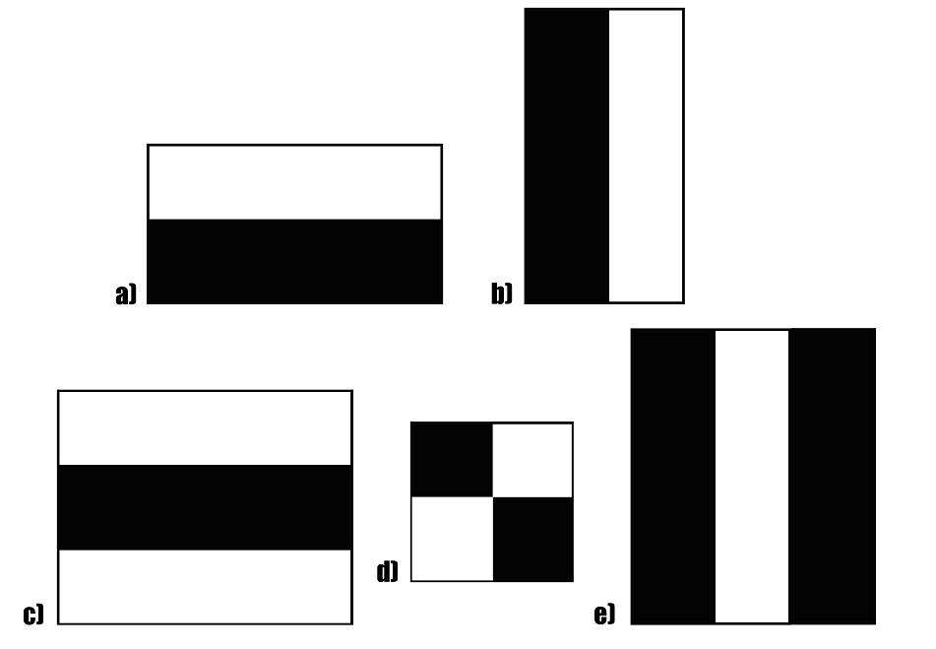

Fig: 5.6 Example for HaarCascade +ve and -ve detection of faces

# Emotion Detection:

The CNN architecture creates by applying filters or feature detectors to the input image, the Relu activation function is used to generate feature maps or activation maps.These filters or feature detectors can identify edges, lines, curves, and other characteristics present in the picture. The feature maps are then subjected to pooling to maintain translation invariance, meaning that even small changes in the input should result in unchanged outputs. While pooling can be performed using minimum, maximum, or average, max-pooling is considered superior in performance compared to the other methods. Finally, the inputs are flattened before being fed into a deep neural network, which outputs the class of the object.

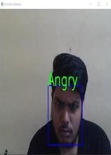 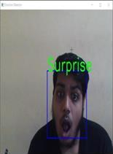

Fig: 5.7 Emotion Screen shots

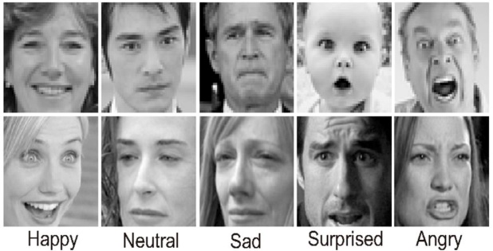

Fig: 5.8 Dataset Image Samples

The Process of analysing the pictorial characteristic of a person.

1. Data Collection: Gather a dataset of labelled images of people. The dataset should be diverse and representative of the population you want to analyse, with a wide range of ages, genders, ethnicities, and body types.
2. Data Pre-processing: Preparations for training the CNN involve several steps such as resizing the images to a consistent size, normalizing pixel values, and dividing the dataset into training and validation sets.
3. Model Training: Perform training of a CNN model on the pre-processed dataset. The CNN architecture should comprise convolutional layers for extracting features, pooling layers for downsampling, and fully connected layers for classification. The specific configuration and number of layers will depend on the chosen CNN architecture.
4. Feature Extraction: Once the CNN is trained, use it to extract features from new images of people. Pass the images through the trained CNN and obtain the output from the desired layer(s) that captures relevant pictorial characteristics such as facial features, body shape, or clothing.
5. Feature Analysis: Analyse the extracted features using appropriate techniques. This may involve statistical analysis, visualization, or other methods to identify patterns, trends, or differences in the features across the dataset. You may also use domain-specific knowledge or external references to interpret the meaning of the features in the context of person characteristics.
6. Model Evaluation: The performance of the CNN model in capturing pictorial characteristics of people. This may involve quantitative metrics such as accuracy, precision, recall, or F1 score, as well as qualitative assessments of the model's ability to accurately represent the pictorial characteristics of the person images.
7. Interpretation: Interpret the findings from the feature analysis and model evaluation to draw conclusions about the pictorial characteristics of the person images. Document and communicate the results of your analysis in a clear and concise manner, and consider the limitations and potential biases of the CNN model and dataset used.

The basic process involves feeding an input image into a CNN model, which then produces the results [10]. A CNN- trained model, with learned weights, is utilized for emotion detection. When a real-time photo is submitted by a user, it is processed by the trained CNN model, which assigns an emotion label to the image based on its prediction.

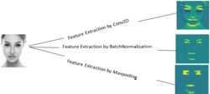

Fig: 5.9 Features Extracted for identification

**6 RESULT & ANALYSIS**

By default, this solution recognizes all faces in the image feed that exhibit emotions. The test accuracy for a straightforward 4-layer CNN was 63.2% after 50 iterations.

There were few overfitting during training due to the high complexity of transfer learning models and the comparatively modest size of the datasets. The ResNet transfer learning model soon over fit to the training data, with train accuracy starting to flatten after only 25 epochs, even though 30% of dropout added in the last three layers.

The model is composed of a softmax output layer, a fully connected layer with dimensions of 1024 by 1024 pixels, and three stages of convolutional and max-pooling layers. The convolutional layers employ filters of sizes 5x5, 4x4, and 5x5 in 32, 32, and 64 layers, respectively. The max-pooling layers utilize kernels of size 3x3. The activation function applied throughout the model is ReLU.

Additionally, batch norm was added at every layer and 30% dropout after the last FC layer to boost performance. Optimize the cross-entropy loss using a momentum of 0.3 to fine-tune the model. Initial learning rates of 0.2, 32, and 0.0001 are pre-determined, as are batch size and weight decay. If the validation accuracy does not increase, the learning rate is cut in half.

An epoch is completed when the neural network processes the entire dataset in a single pass, encompassing both the forward and backward propagation steps.

**7 CONCLUSIONS**

The programme seeks to give operating system users a more user-friendly, versatile, and dependable an emotion-driven music system designed for individuals seeking music that aligns with their emotions and emotional behavior. would benefit from the Emotion-based Music Program. It could aid in reducing the amount of time spent searching for music, decreasing the amount of time wasted on computing, and ultimately improving the system's accuracy and efficiency. By employing a camera to capture the image, identifying the end-emotion, user's and providing a personalised playlist, it makes the end-job user's easier.

With the help of this initiative, machine learning technology will advance significantly. The purpose of an emotion-based music player is to organise the music according to the user's emotions, such as happiness or sadness.

**8 FUTURE IDEAS**

While the current system is fully operational, there are still opportunities for future enhancements. The application can be modified in various ways to enhance the overall user experience and achieve improved results. Some of these use an alternate approach based on extra emotions such as disgust and fear that are not included in the model.

The system's future objectives involve developing a mechanism that can assist in the treatment of individuals dealing with mental stress, anxiety, acute depression, and trauma through music therapy. Additionally, there is an opportunity for further enhancement to address the current system's limitations, such as poor camera resolution and performance in extremely low light conditions, by incorporating additional functionality as a potential solution in the future.

In the future, this might be improved and added to iPods and other similar gadgets, making it much more practical.

**9 LIMITATIONS**

As a result of the limited quantity of photos in the utilized image dataset, the system currently faces challenges in accurately capturing all emotions. In order for the classifier to generate precise outcomes, it requires images that are captured in well-lit environments. The classifier can accurately estimate the user's sentiment if the image quality is at least higher than 320p.

**10 ADVANTAGES OF PROPOSED SYSTEM**

* + Users do not need to select songs manually.
  + No need of existing playlist.
  + Users do not need to classify

References

1. Preema J.S, Rajashree, Sahana M, Savitri H, Review on facial expression-based music player, International Journal of Engineering Research & Technology (IJERT), ISSN- 2278-0181, Volume 6, Issue 15, 2018.
2. AYUSH Guidel, Birat Sapkota, Krishna Sapkota, Music recommendation by facial analysis, February 17, 2020.
3. CH. sadhvika, Gutta.Abigna, P. Srinivas reddy, Emotion-based music recommendation system, Sreenidhi Institute of Science and Technology, Yamnampet, Hyderabad; International Journal of Emerging Technologies and Innovative Research (JETIR) Volume 7, Issue 4, 2020.
4. Julian Menezes .R, Albert Mayan .J, M. Breezely George,” Development of a Functionality Testing Tool for Windows Phones”, Indian Journal of Science and Technology,Vol:8,Issue:22,pp: 1-7, 2015.
5. Vincent Tabora, Face detection using OpenCV with Haar Cascade Classifiers, Becominghuman.ai,2019.
6. Zhuwei Qin, Fuxun Yu, Chenchen Liu, Xiang Chen. How convolutional neural networks see the world - A survey of convolutional neural network visualization methods. Mathematical Foundations of Computing, 2018.
7. Frans Norden and Filip von Reis Marlevi, A Comparative Analysis of Machine Learning Algorithms in Binary Facial Expression Recognition, TRITA-EECS-EX- 2019:143.
8. Ahmed Hamdy AlDeeb, Emotion- Based Music Player Emotion Detection from Live Camera, ResearchGate, 2019.
9. Mary Posonia A, S. Vigneshwari, Albert Mayan J, D. Jamunarani,"Service Direct: Platform that Incorporates Service Providers and Consumers Directly",International Journal of Engineering and Advanced Technology (IJEAT) , Vol.8 ,No.6,pp.3301-3304,2019.
10. John, A.M.,Prince Mary, S., Mohana Prasad, K., Naveena, M. and Laveti, N. (2022),‘Authentication for cloud computing system through smartcard’, Int. J. Cloud Computing, Vol. 11, Nos. 5/6, pp.518–528.
11. Albert Mayan J, Karthikeyan S, Nikhil Chandak, Bharat Mundhra and Padmavathy J, "Facial attendance system technology using Microsoft Cognitive Services”, International Journal of Engineering Systems Modelling and Simulation, Vol. 12, Nos. 2/3, pp. 180-187 ,2021
12. Yusuf Yaslan, Deger Ayata, Mustafa E. Kamasak, Emotion Based Music Recommendation System Using Wearable Physiological Sensors, IEEE journal, Volume 64, Issue 2, May 2018.
13. Mendel, N. 2020. Facial Emotion Recognition Using Convolutional Neural Networks (FERC). Springer Nature Switzerland AG